|  |  |  |
| --- | --- | --- |
| **LAB 321 Assignment** | **Type:** | **Long Assignment** |
| **Code:** | **3** |
| **LOC:** | **500** |
| **Slot(s):** | **12** |

**Title:** Browse image gallery like Pinterest

**Background**

Pinterest is an online service that allows you to share images through social networking. An example of Pinterest is the website where you have a "pinboard" that allows you to post ideas that you want to remember and then share them with your friends through

**Program Specifications**

Program a web site displaying list of images like pinterest

**Features:**

This website contains following main functions

* Function 1: Display images
  + Images gallery have many other of sizes
  + Display images on page in 5 columns
  + All images have same width and difference height
  + Display image with image description
  + When user scroll down other images appear (load image continuously and dynamically)

Database description

* Image URL
* Image description

***Expectation of User interface:***

PIC 1 : Image browsing

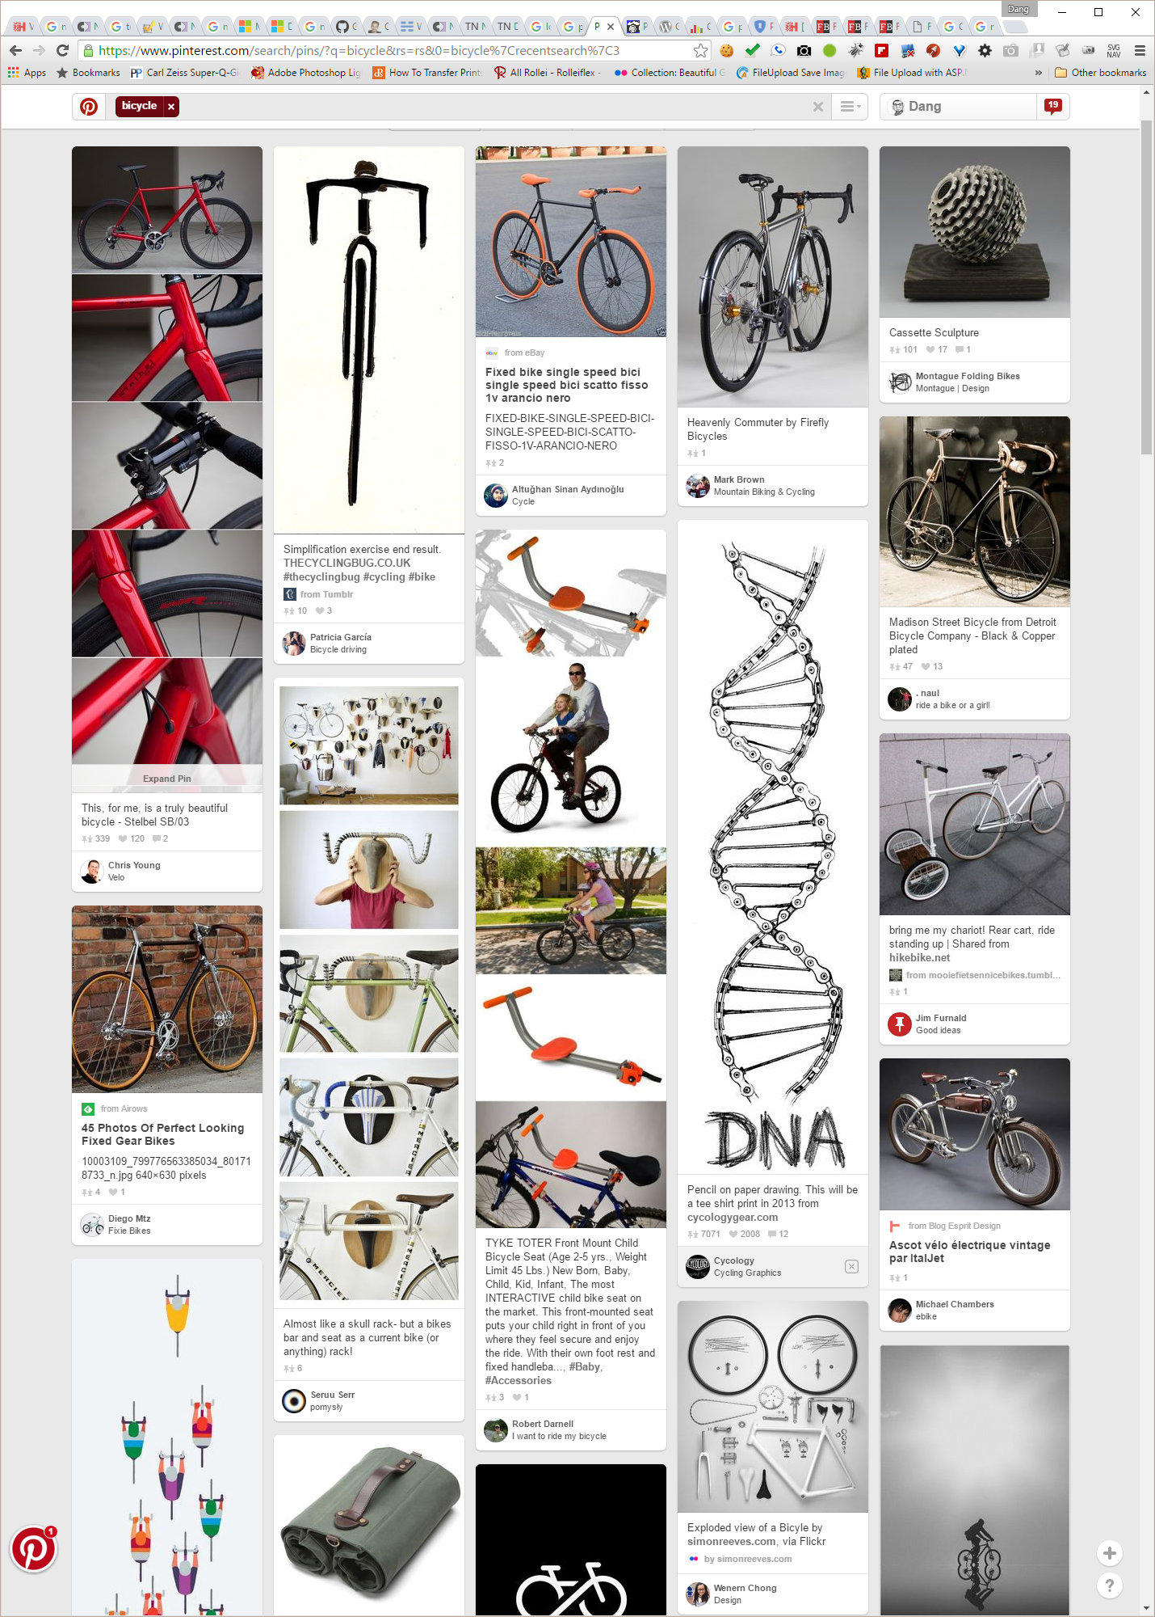

**Guidelines**

* Step 1 : Create web layout
* Step 2 : Create prototype
* Step 3 : Design database base on created prototype
* Step 4 : Code & Test